## Amrita Vishwa Vidyapeetham Amrita School of Engineering, Bengaluru



Department of Computer Science and Engineering Report

## TOPIC: Developing Network model for educational institution

***Submitted by***

**BL.EN.U4CSE20067 Revanth K**

**BL.EN.U4CSE20160 Siddhardha Anagani**

**BL.EN.U4CSE20198 Sumanth K**

## ABSTRACT:

The case study of the following report tells us about the study of how an internal network of an educational institute which consists of 5 different networks which are in the college in different sections and in the following study we discuss about the establishment of the connections with each other using switches connected to routers and routers connected to servers internally to maintain the communication between each department. We assign IP addresses to each and every device present in the institution so that its easy to know the track. And we use CISCO PACKET TRACKER to know how the transfer is done.

## INTRODUCTION:

The system is about designing a topology of a network that is a Local Area Network for a Institution which consists of multiple departments which are interconnected to each other and they communicate with each other by transferring and receiving the data. In order to achieve this system for an educational Institute we use Network systems which satisfy all the necessities of the client. The computer network system comes with a vivd range of options which make the system easy to communicate and in this system we see how the packets are transferred from one department to another and how does the DNS server work to open a web server.

## THE CLINET REQUIREMENTS:

## The client requires a system which consists of five departments that consists of multiple working pc’s ,printers and hubs. The client wants to have a scalable network and the system needs support even in remote cases.

# Rough Diagram:

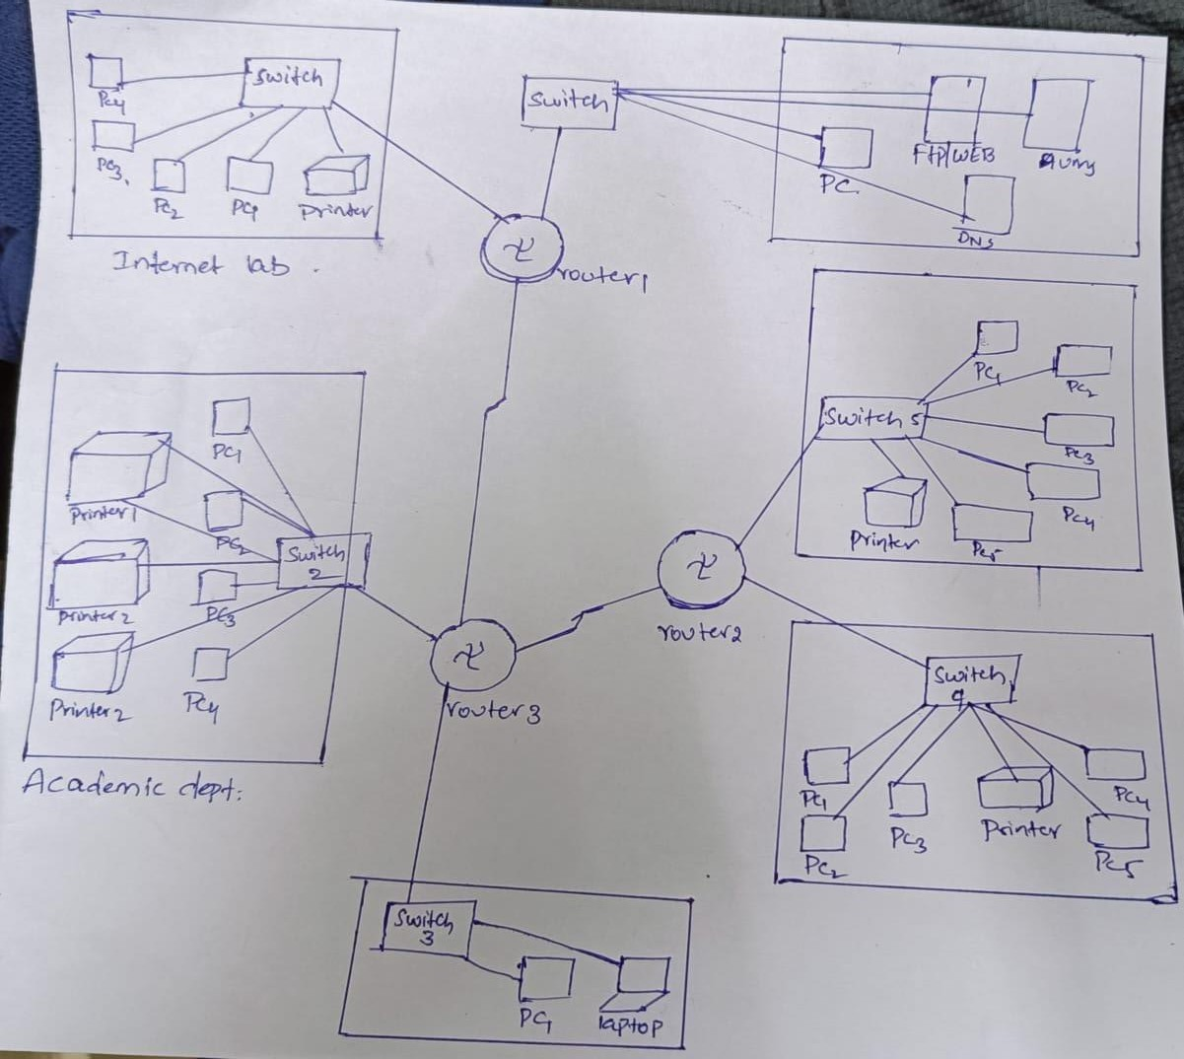

## DEVICE DETAILS:

For our case study we utilized Switch PT which interfaces the switches of model name switch PT. we utilized three sorts of servers (FTP/WEB, DNS, AUMS).For associating gadgets we utilized copper straight through link and for interfacing switches we utilize sequential DTE link.

## CONNECTION DETAILS:

### As the foundation comprises of various divisions every division doled out to various organization address for the information move and a default gateway for every division.

### Connection Details of each departments :

1. **Internet lab**

The IP address of this department is subneted through the IP address: 128.168.0.0

The default gate way of this department: 128.168.0.1 Subnet mask: 255.255.0.0

IP Address of DNS : 1.0.0.2

The IP address of each device is shown below :

|  |  |  |  |
| --- | --- | --- | --- |
| Device Name | IP address | Default gate way | Subnet mask |
| PC2 | 128.168.0.2 | 128.168.0.1 | 255.255.0.0 |
| PC3 | 128.168.0.3 | 128.168.0.1 | 255.255.0.0 |
| PC4 | 128.168.0.4 | 128.168.0.1 | 255.255.0.0 |
| PC5 | 128.168.0.5 | 128.168.0.1 | 255.255.0.0 |
| Printer5 | 128.168.0.6 | 128.168.0.1 | 255.255.0.0 |

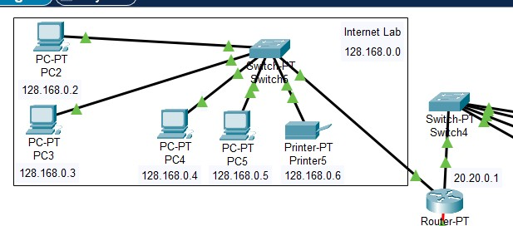

### ICTS

The IP address of this department is subnetted through the IP address: 192.168.1.0

The default gate way of this department: 192.168.1.1 Subnet mask: 255.255.255.0

IP Address of DNS: 1.0.0.2

The IP address of each device is shown below:

|  |  |  |  |
| --- | --- | --- | --- |
| Device Name | IP address | Default gate way | Subnet mask |
| LAB1 | 192.168.1.3 | 192.168.1.1 | 255.255.255.0 |
| LAB2 | 192.168.1.4 | 192.168.1.1 | 255.255.255.0 |
| LAB3 | 192.168.1.5 | 192.168.1.1 | 255.255.255.0 |
| LAB4 | 192.168.1.6 | 192.168.1.1 | 255.255.255.0 |
| HOD CABIN | 192.168.1.2 | 192.168.1.1 | 255.255.255.0 |
| PRINTER | 192.168.1.7 | 192.168.1.1 | 255.255.255.0 |

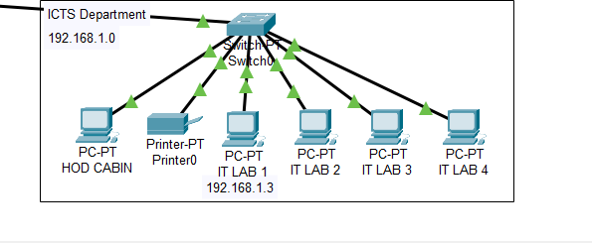

### C) CSE Department

The IP address of this department is subnetted through the IP address: 192.168.2.0

The default gate way of this department: 192.168.2.1 Subnet mask: 255.255.255.0

IP Address of DNS: 1.0.0.2

The IP address of each device is shown below:

|  |  |  |  |
| --- | --- | --- | --- |
| Device Name | IP address | Default gate way | Subnet mask |
| LAB1 | 192.168.2.3 | 192.168.2.1 | 255.255.255.0 |
| LAB2 | 192.168.2.4 | 192.168.2.1 | 255.255.255.0 |
| LAB3 | 192.168.2.5 | 192.168.2.1 | 255.255.255.0 |
| LAB4 | 192.168.2.6 | 192.168.2.1 | 255.255.255.0 |
| HOD CABIN | 192.168.2.2 | 192.168.2.1 | 255.255.255.0 |
| PRINTER | 192.168.2.7 | 192.168.2.1 | 255.255.255.0 |

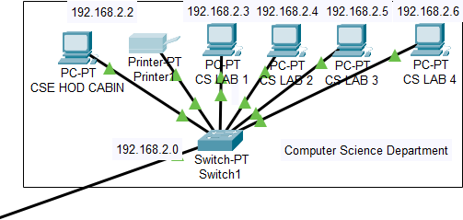

### Academic coordinator

The IP address of this department is subnetted through the IP address: 192.168.3.0

The default gate way of this department: 192.168.3.1 Subnet mask: 255.255.255.0

IP Address of DNS: 1.0.0.2

The IP address of each device is shown below:

|  |  |  |  |
| --- | --- | --- | --- |
| Device Name | IP address | Default gate way | Subnet mask |
| OFFICE | 192.168.3.2 | 192.168.3.1 | 255.255.255.0 |
| EXAM CELL | 192.168.3.3 | 192.168.3.1 | 255.255.255.0 |
| TPO | 192.168.3.5 | 192.168.3.1 | 255.255.255.0 |
| ENQUIRY | 192.168.3.4 | 192.168.3.1 | 255.255.255.0 |
| PRINTER3 | 192.168.3.6 | 192.168.3.1 | 255.255.255.0 |
| PRINTER2 | 192.168.3.7 | 192.168.3.1 | 255.255.255.0 |
| PRINTER4 | 192.168.3.8 | 192.168.3.1 | 255.255.255.0 |

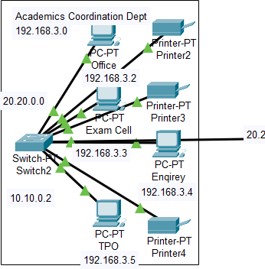

### Administration department:

The IP address of this department is subnetted through the IP address: 192.168.4.0

The default gate way of this department: 192.168.4.1 Subnet mask: 255.255.255.0

IP Address of DNS: 1.0.0.2

The IP address of each device is shown below:

|  |  |  |  |
| --- | --- | --- | --- |
| Device Name | IP address | Default gate way | Subnet mask |
| PC0 | 192.168.4.2 | 192.168.4.1 | 255.255.255.0 |
| LAPTOP 0 | 192.168.4.3 | 192.168.4.1 | 255.255.255.0 |

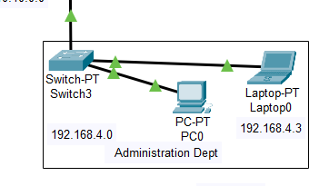

### Server room:

It consists of three servers (FTP/WEB, DNS, AUMS) and a PC. These are connected to a switch and the switch is directly to router.

The department is subnet through: 1.0.0.0 Default gateway of the server room: 1.0.0.1 Subnet mask :255.0.0.0

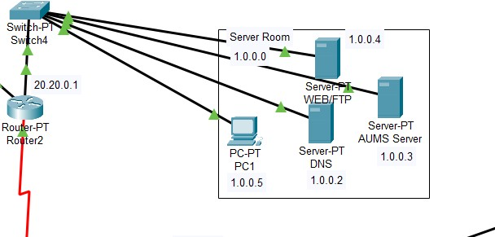

## Configuration of routers:

**Router 0:**

Fast ethernet 0/0:

Ip address: 192.168.1.1 Subnet mask:255.255.255.0

Fast ethernet 1/0:

Ip address: 192.168.2.1 Subnet mask:255.255.255.0

Serial 2/0:

Ip address : 10.10.0.1 Subnet mask:255.0.0.0

### Router 1:

Fast ethernet 0/0:

Ip address: 192.168.3.1 Subnet mask:255.255.255.0

Fast ethernet 1/0:

Ip address: 192.168.4.1 Subnet mask:255.255.255.0

Serial 2/0:

Ip address : 10.10.0.2 Subnet mask:255.0.0.0

Serial 3/0:

Ip address : 20.20.0.1 Subnet mask:255.0.0.0

### Router 2:

Fast ethernet 0/0:

Ip address: 1.0.0.1 Subnet mask:255.0.0.0

Fast ethernet 1/0:

Ip address: 128.168.0.1 Subnet mask:255.255.0.0

Serial 2/0:

Ip address: 20.20.0.2 Subnet mask:255.0.0.0

## Routing Information Protocol (RIP):

Routing Information Protocol is a dynamic routing protocol which runs on hop count as a routing metric to find the best suitable path between sources and the destination network. It has AD value of 120 and works on the application layer and OSI model and it’s a distant vector routing protocol.

## For Router0:

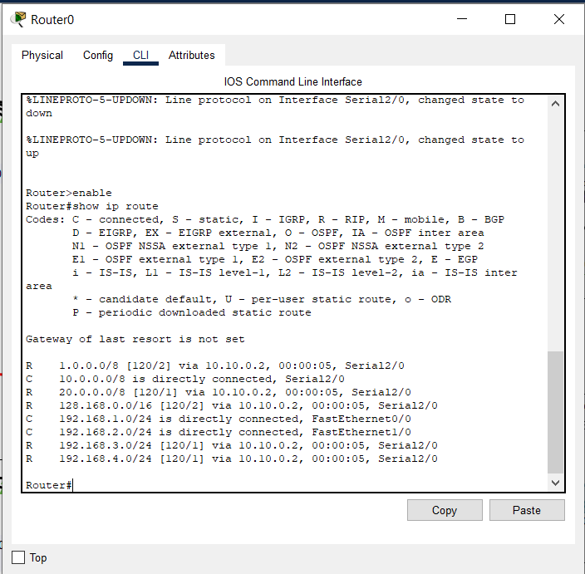

**For router 1:**

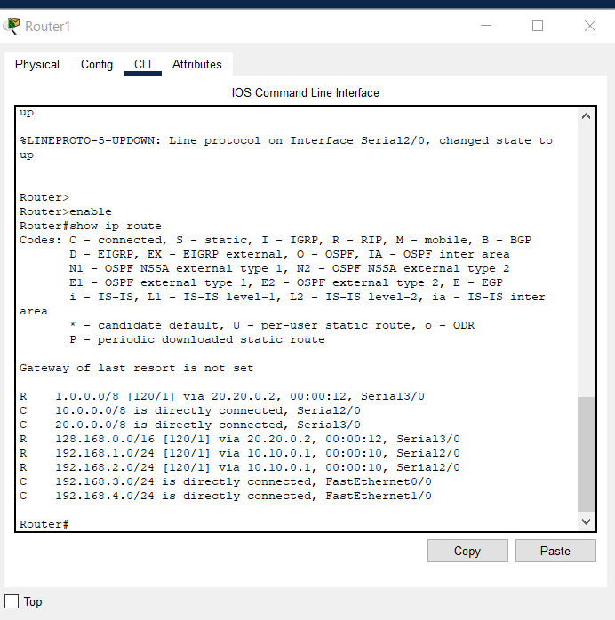

# Router 2:

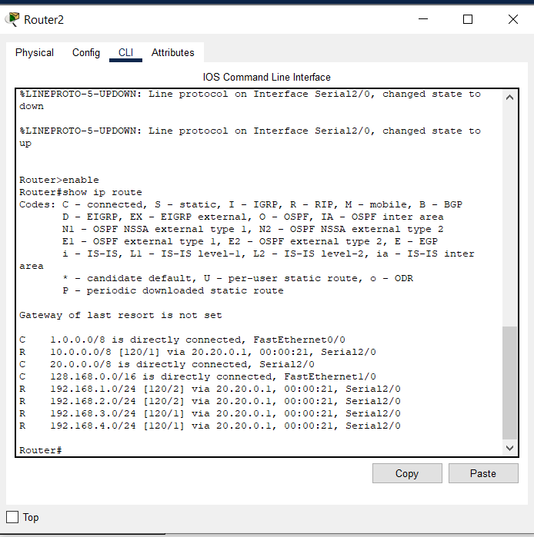

## Testing VLAN communication from HOD cabin in ICTS to internet lab of PC3:

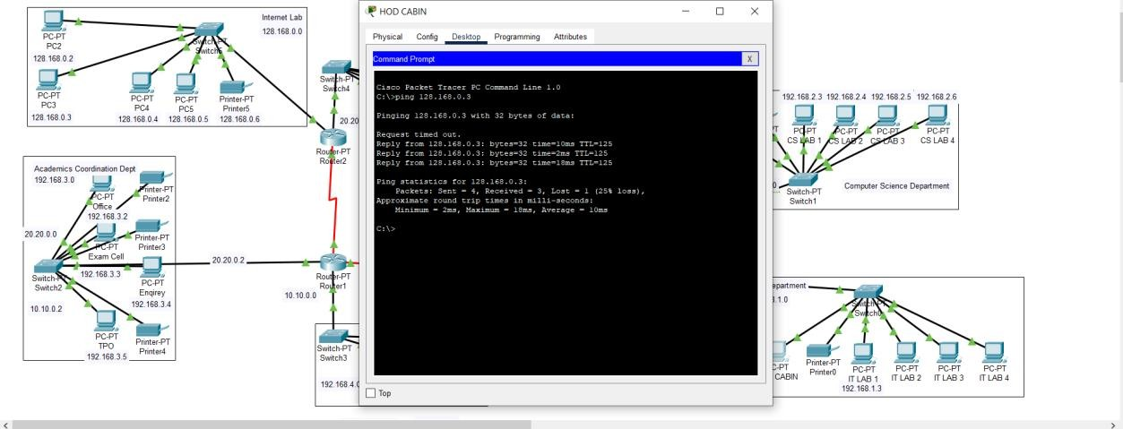

**Packet transmission from one pc to another pc of different department:**

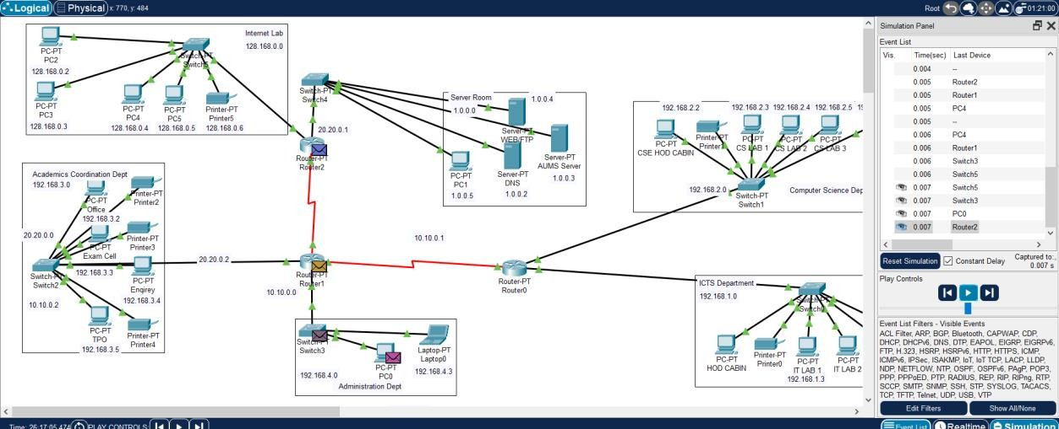

## Testing web server:

1. **AUMS.COM**

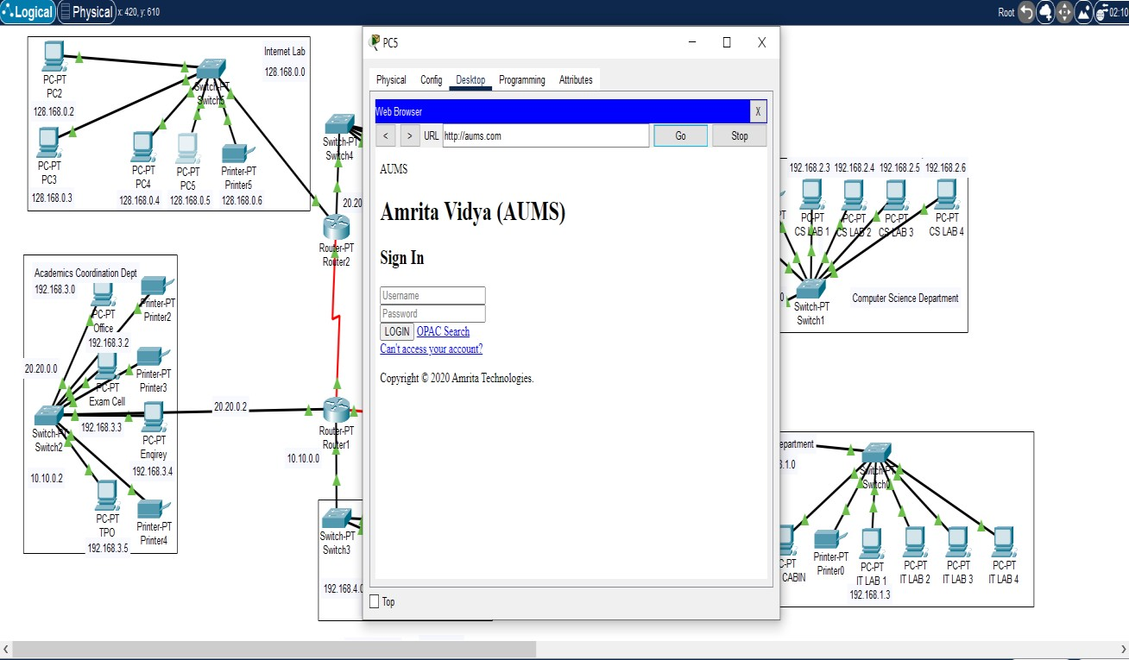

# welcome.com

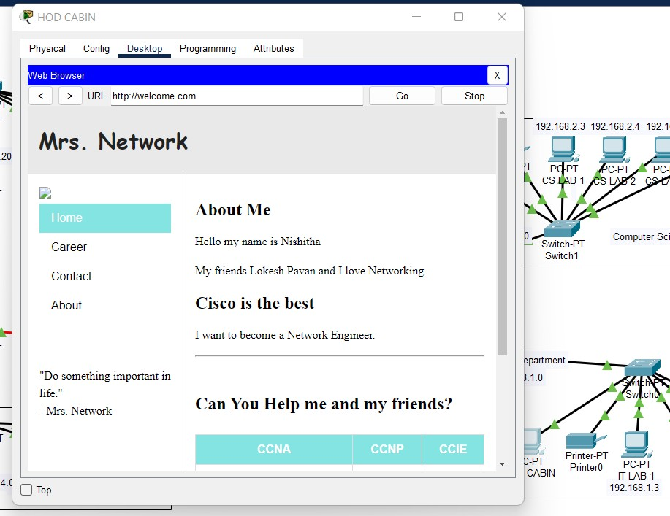

**Implementation of design on CISCO PACKET TRACER:**

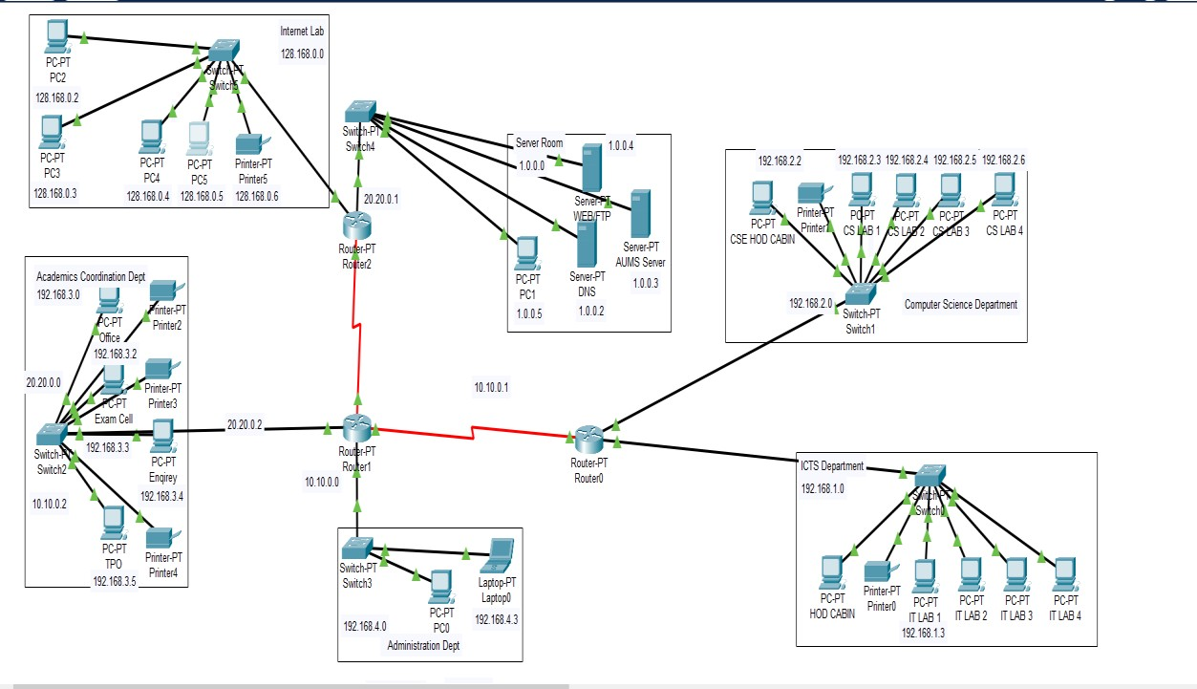

# Simulation:

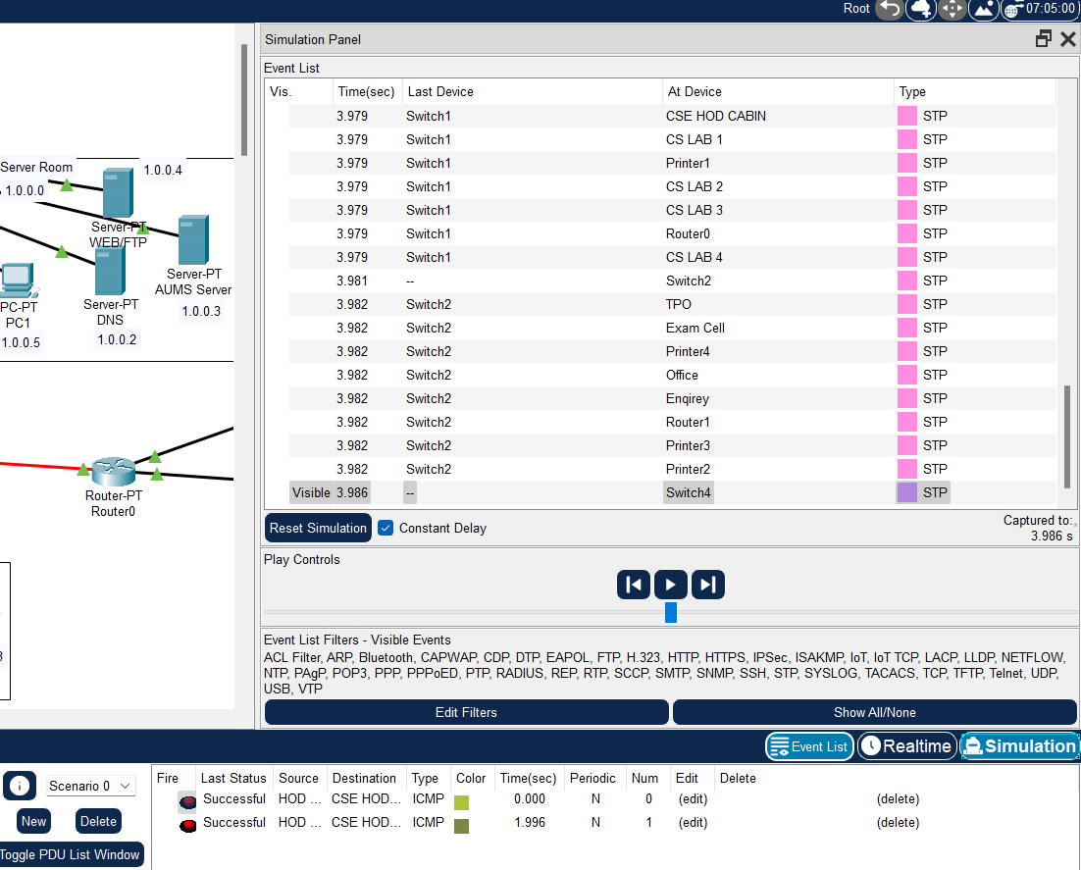

**Capturing packets in wire shark:**

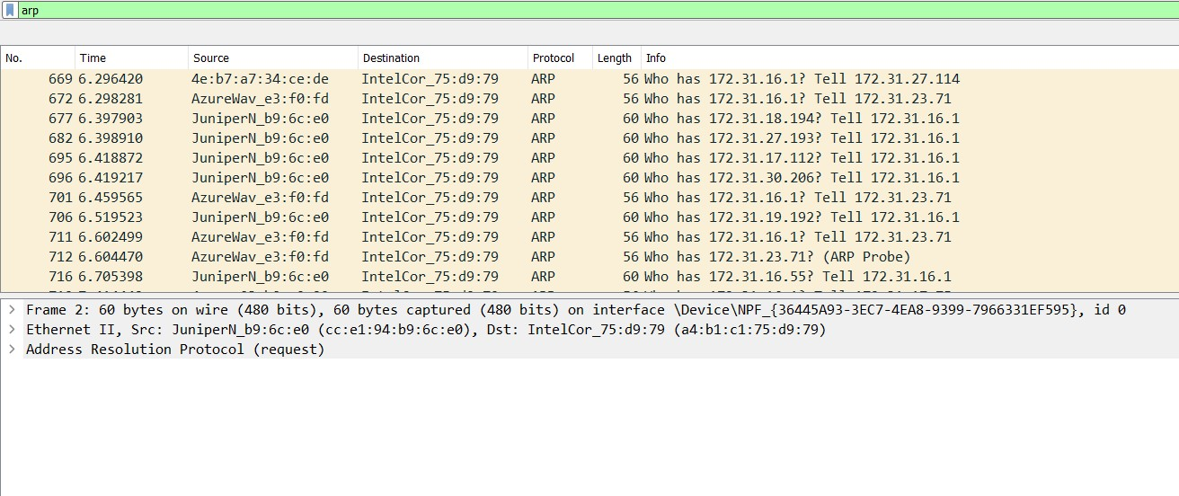

**ARP protocol was used to map IP address to MAC address**

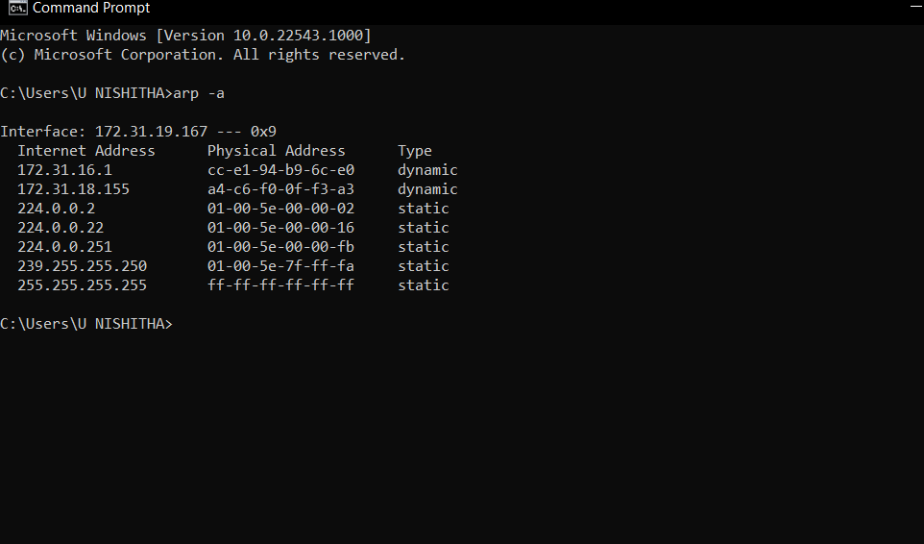

# TRACING IP ADDRESS IN WIRE SHARK:

# Initially we send a packet from one to another node in the system and then we have to disable all the filters to capture a packet in wire shark and enable the ARP(Address resolution protocol) then we filter and start wireshark capturing and then we filter the ARP packets in wireshark , and then we will be able to see the captured packets.



Here for the packet communication cisco packet tracer uses the system arp’s.



# Conclusion:

The main agenda of the system generated is to build an infrastructure that is readily available to access to information and security of the private network, and keeping the speed and productivity under consideration we have installed equipment allowed to organize high-speed wired and wireless Internet access throughout the Institution buildings and also having a high flexibility to communicate between each block with all types of data using a single optimized network.